Instruções

No frp_identity, cliente.lua

Comentar essas linhas em amarelo na função **Destroy**:

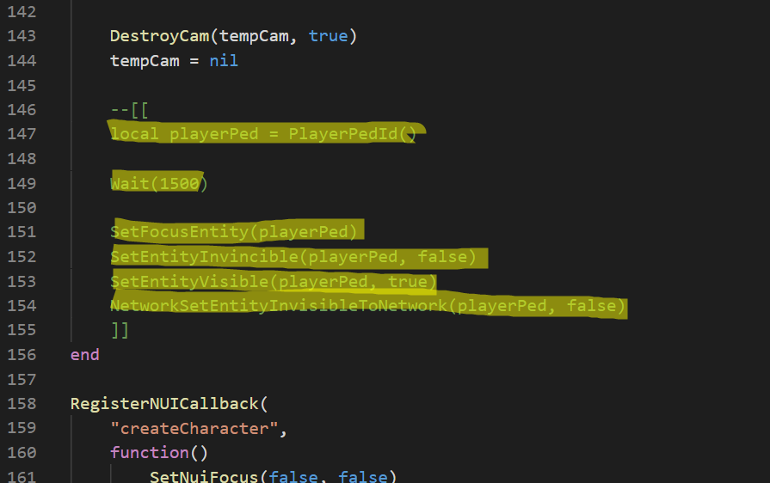

Comentar essas em amarelo na função **spawnCharacterSelected** e adicionar essa linha:

*TriggerServerEvent("FRP:LOGIN:LoginMenu", charId)*

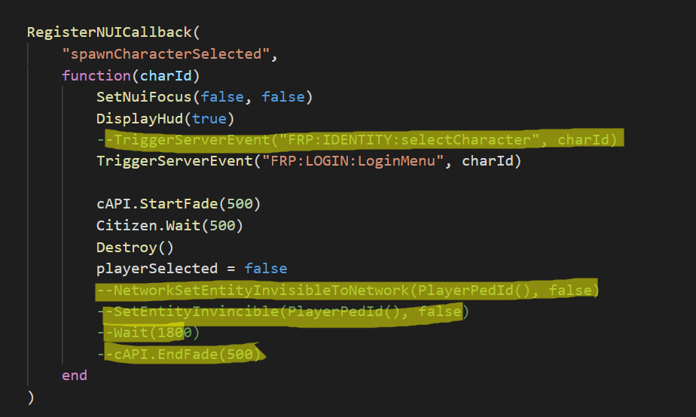

Em _core > server > class, User.lua adicionar essas linhas

*self.setCharacterData = function(this, cid, targetName, key, value)*

*API_Database.query("FCRP/SetCData", {target = targetName, key = key, value = value, charid = cid})*

*end*

*self.getCharacterData = function(this, cid, targetName, key)*

*if key == nil then*

*key = "all"*

*end*

*local rows = API_Database.query("FCRP/GetCData", {target = targetName, charid = cid, key = key})*

*if #rows > 0 then*

*return json.decode(rows[1].Value)*

*else*

*return ""*

*end*

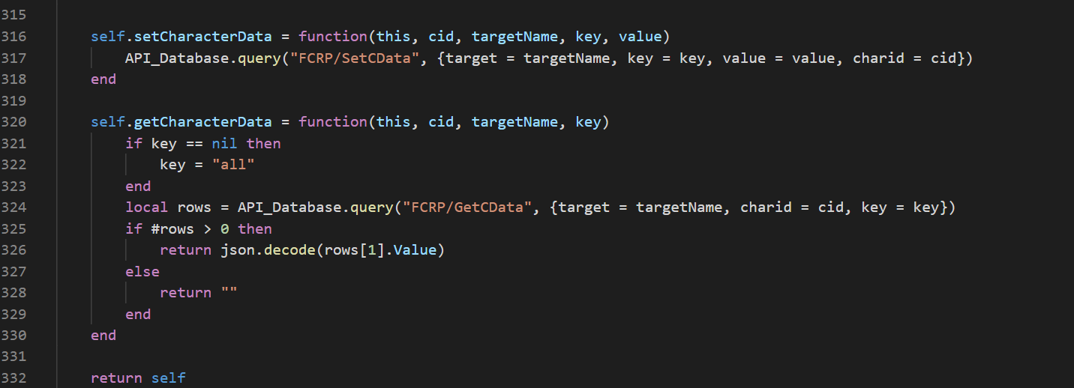

No _core > server > Main.lua adicionar

function API.isCharIdLogged(charid)

    if API.chars[charid] then

        return API.chars[charid]

    end

    return nil

end

No _core > cliente > Player.lua, função **cAPI.Initialize** comentar a linha cAPI.PlaySkyCameraAnimationAtCoords(decodedLastPosition)

Citizen.CreateThread(

        function()

            --cAPI.PlaySkyCameraAnimationAtCoords(decodedLastPosition)

            cAPI.PlayerAsInitialized(true)

        end

    )

Adicionar o frp_login e chamar no server.cfg

ensure frp_login